AIRE (Architecture Intake Review Engine) documentation

Details are subject to change.

Requirements

* Early Engagement support function
* Generate intake forms based on an operational plan file and a template + put date and the name of the intake form at the additional page for tracking (as solution branches might change the name)
* Compare old and new operational plan files (on every generation, need to archive used operational plan data for comparison (xlsx, pickle, json, etc))
* Generate a comparison report – xlsx (shows changed cells) and word (shows changed initiative numbers, details, and so on)
* Extract data from the operational plan based on the column name, not by the index number, so that even if new columns are added to the operational plan, intake forms can be generated without issue.
* Pre-AGP 0 support function
* Generate an assessment report based on an assessment file and a template
* Improve the similarity algorithm (semantic analysis, etc)
* AGP 0 support function
* Check the AGP0 requirements of an AGP 0 submission (zip file)

Folder Structure

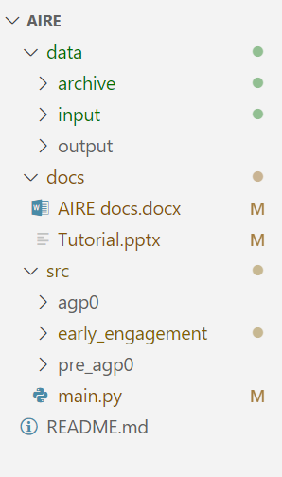

Architecture

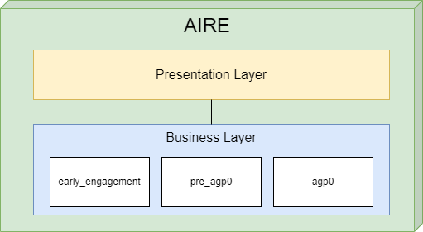

Business Layer – early_engagement

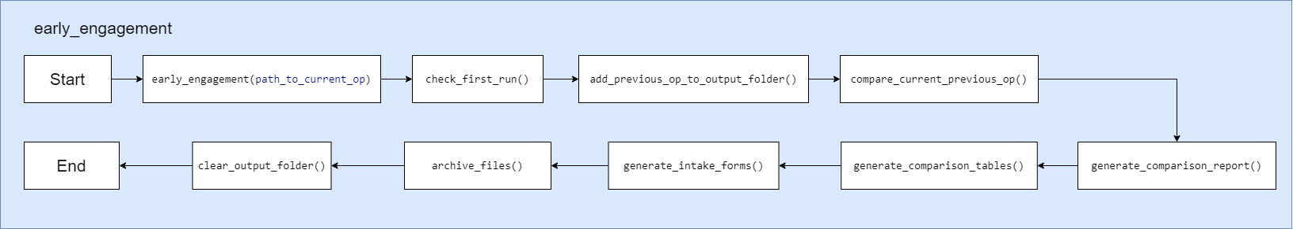

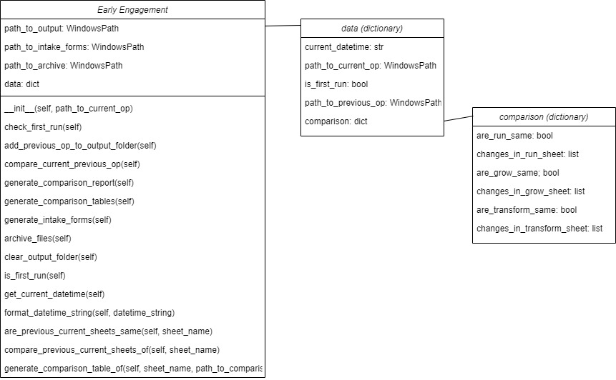

Process

early_engagement

1. **__init__(self, path_to_current_op):**

        1. Receives a path to an operational plan file

        2. Initializes [data] dictionary variable

        3. Put current datetime into [data]

        4. Copy the received operational plan file to the output folder

        5. Put the path to the operational plan file in the output folder into [data]

2. **check_first_run(self):**

        1. Check whether there was a previous run by checking the archive folder

3. **add_previous_op_to_output_folder(self):**

        1. Copy the previous operational plan file in the archive folder into the output folder

        2. Add the path to the previous operational plan file in the output folder to [data]

4. **compare_current_previous_op(self):**

        1. Compare the previous and current operational plans

        2. Initializes [comparison] dictionary variable

        2. Put comparison results (same or not, changed cell location and values if there is any) into [comparison]

        3. Put [comparison] into [data]

5. **generate_comparison_report(self):**

        1. Generate a Word Document object

        2. Iterate through [data] to put information into the Word Document object

        3. Save the Word Document object as a Word file in the output folder.

6. **generate_comparison_tables(self):**

        1. Make a copy of the current operational plan file to use it to describe the changed cells

        2. If one of the sheets (RUN/GROW/TRANSFORM) are changed, compare the previous and current operational plan files of the changed sheet, highlight the changed cells,and write both previous and current values in the copied file

7. **def generate_intake_forms(self):**

To Be Developed

8. **def archive_files(self):**

        1. Make a zip file of the output folder and put it in the data/archive folder

        2. Save the current operational plan file in the data/archive folder for the next run (will be used as a previous operational plan)

9. **def clear_output_folder(self):**

        1. Delete all the files in the output folder for the next run